## Prerequisites:

1. PyCharm installed (at least a 2018 version).
2. Python installed.
   1. Run “python --version” in cmd to check if python is installed.

## Steps:

1. “Create new project” in PyCharm.Create a new environment using venv (Virtual Environment). Make sure that the location of the python interpreter is provided in “Base Interpreter”. Create the project.

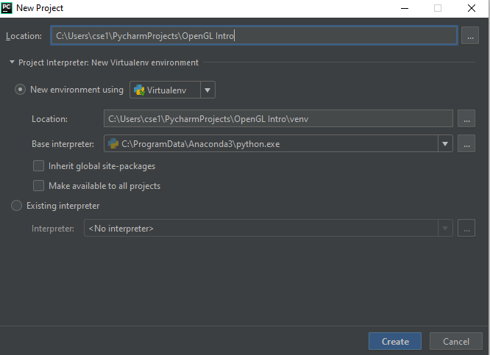

1. Right click on the project directory and create a new python file. You can name it “main”.

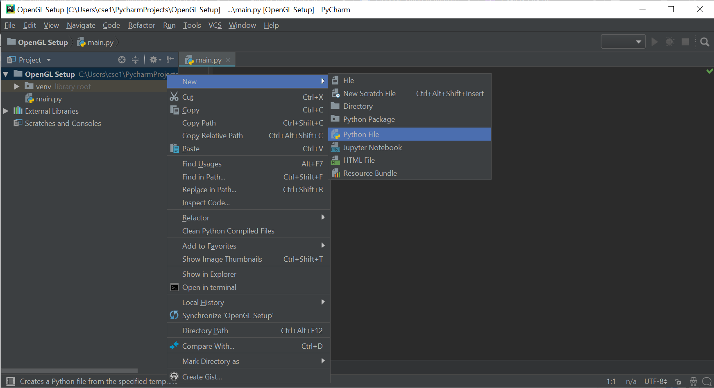

1. Now you need to create configuration for main.py. Select Edit Configuration as shown in the picture.

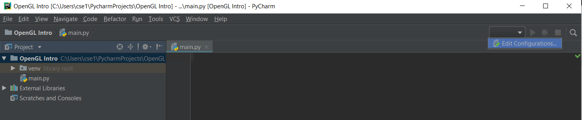

1. Add new python configuration as shown below.

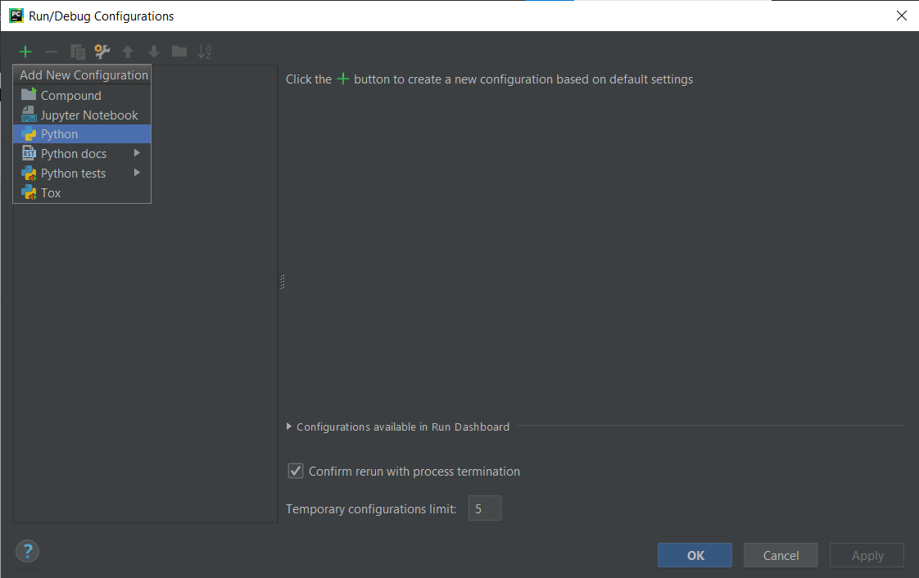

1. Set the “Script path” as the python file (main.py) in the project directory. The working directory will be set automatically. Notice the Python version in the Python Interpreter field. Let’s say the python version is 3.x. Press “Ok” to confirm the configuration.

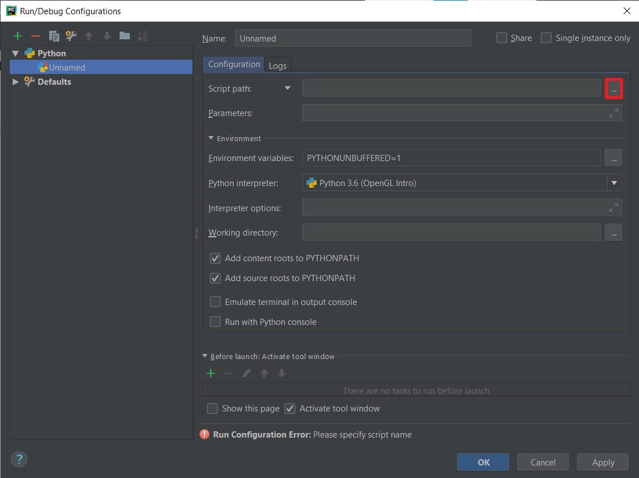

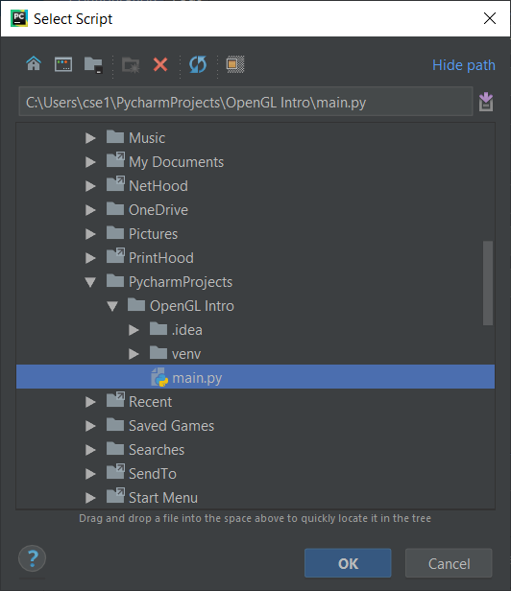

1. At this point, run any sample python code to ensure that the Python interpreter is configured correctly.

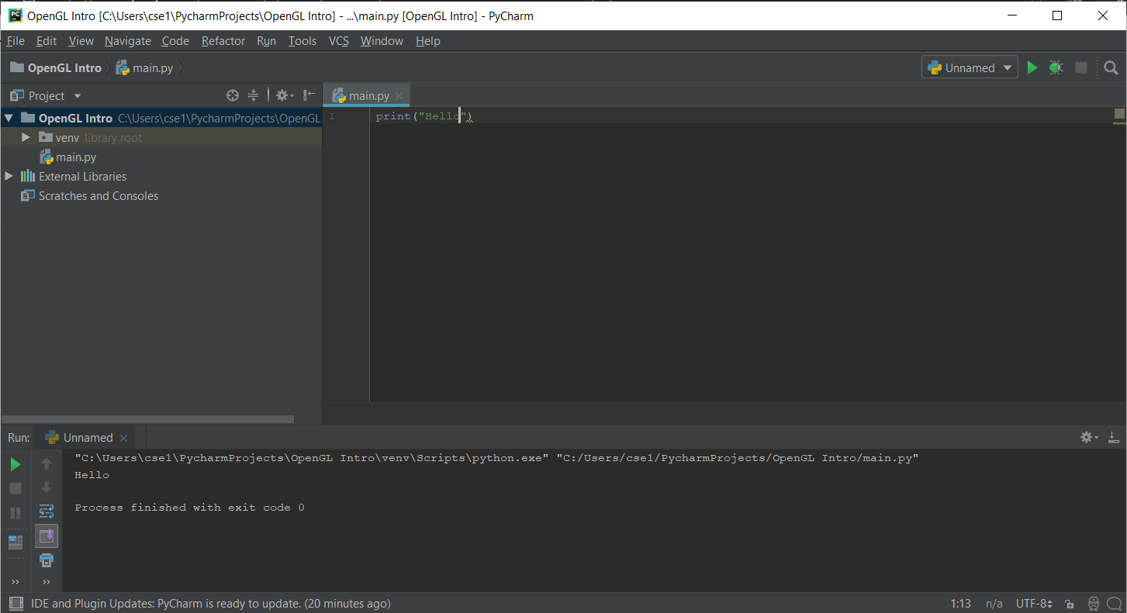

1. Go to the following link: [Python Extension Packages for Windows - Christoph Gohlke (uci.edu)](https://www.lfd.uci.edu/~gohlke/pythonlibs/#_pyopengl:~:text=PyOpenGL%E2%80%913.1.5%E2%80%91cp36%E2%80%91cp36m%E2%80%91win_amd64.whl) and download the files with names as below:

PyOpenGL‑3.1.6‑cp3x‑cp3x‑win_amd64.whl

* PyOpenGL_accelerate‑3.1.6‑cp3x‑cp3x‑win_amd64.whl

when your python version is 3.x

For example, if your python version is 3.6, replace 3x with 36.

1. To open the project directory, right click the python file (main.py) and select Open in → Explorer. Note that the “main.py” and venv are located in the project directory. Now cut and paste the downloaded files there.

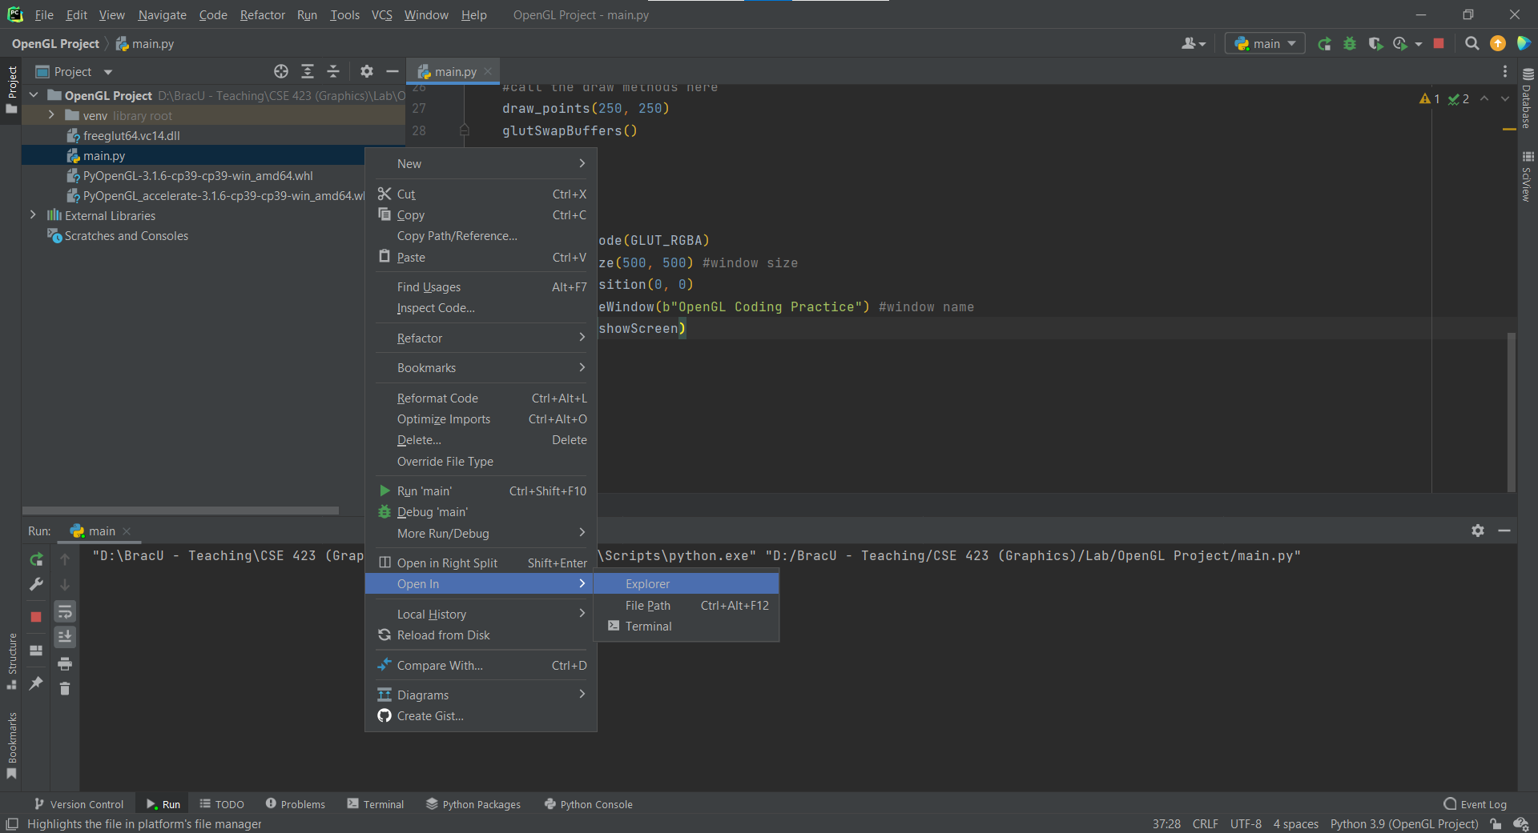

1. Open the PyCharm terminal (see figure) and run the following commands:

pip install PyOpenGL-3.1.5-cp3x-cp3xm-win_amd64.whl

pip install PyOpenGL_accelerate-3.1.5-cp3x-cp3xm-win_amd64.whl

[Replace 3x with your respective version of the downloaded file.]

Now openGL is installed.

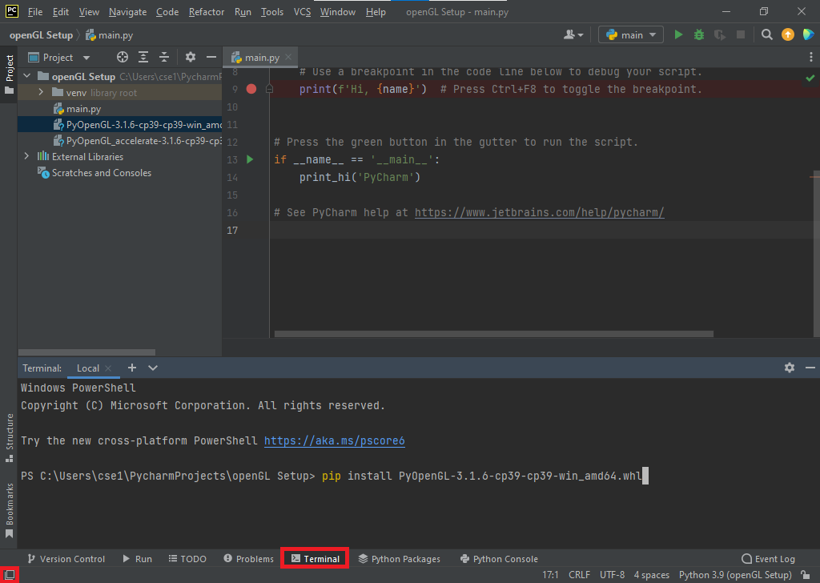

1. Copy the following template code into the editor (main.py file):

<https://drive.google.com/file/d/1r4y45o2C4ghNaBmGf0WAjOo3ZNuwEdCn/view?usp=sharing>

Run the code and if you can see the following output, then your openGL setup is complete.

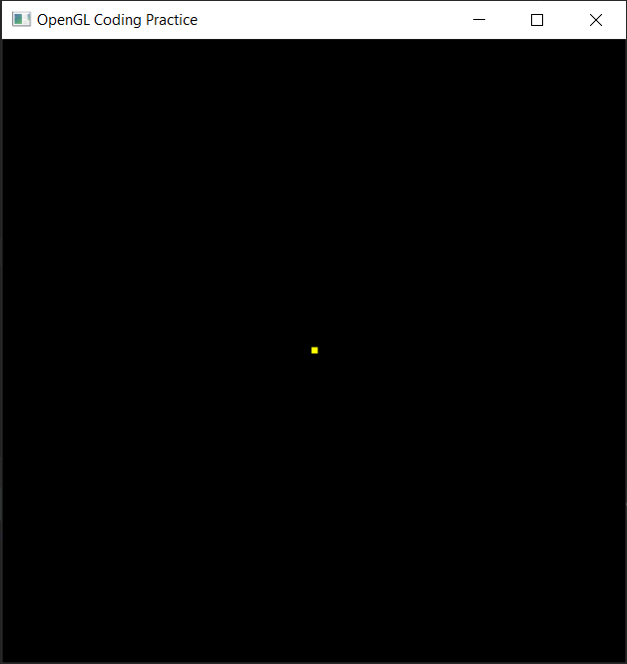

## Troubleshooting-1: After opening the PyCharm terminal in step 9, the following message is shown:

activate.ps1 cannot be loaded because running scripts is disabled on this system.

1. Right click on Windows PowerShell and select “Run as administrator.”

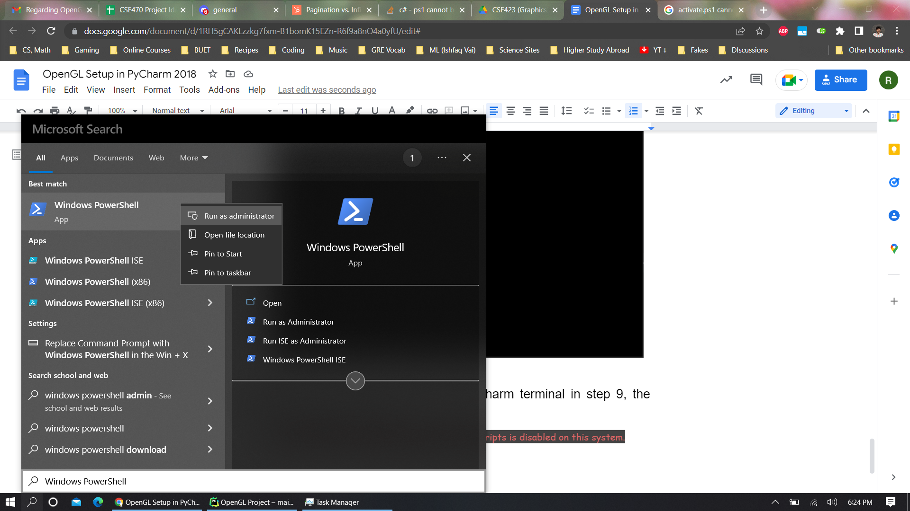

1. Run the following command in PowerShell:

Set-ExecutionPolicy -Scope CurrentUser -ExecutionPolicy Unrestricted

1. Resume from **step 9**.